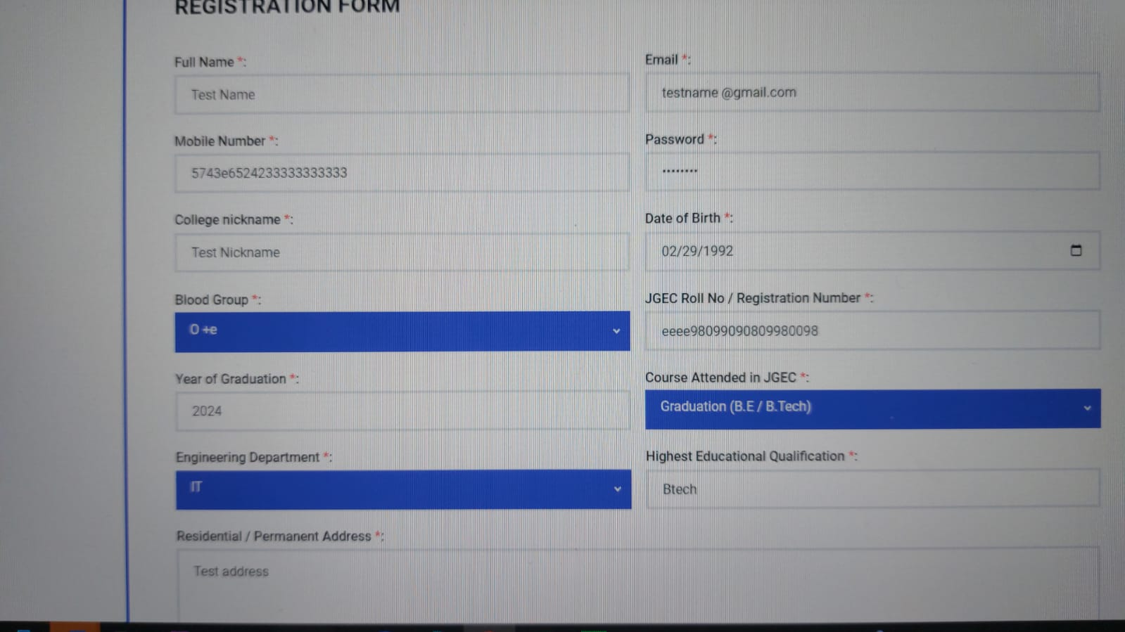

1.Registration page - mobile no field is still taking alphabets, no range check. Blood group is "O +e" should be fixed to "O +ve" ::done

2.Mobile number is fine.. on clicking register it gives the error in image

clicked on register and my account got created without approval.

Testname@gmail.com

Password Hello123::done

There should be a functionality to edit profile (to update mobile/email in future) and forgot password functionality. ::done

3.When no search results are there, system should return a relevant message."No results found" done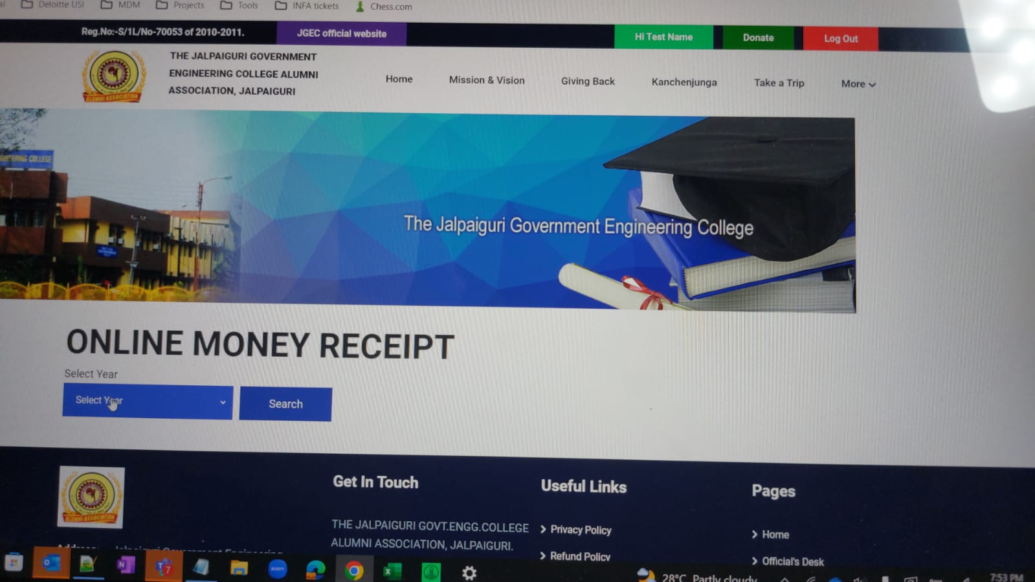

4.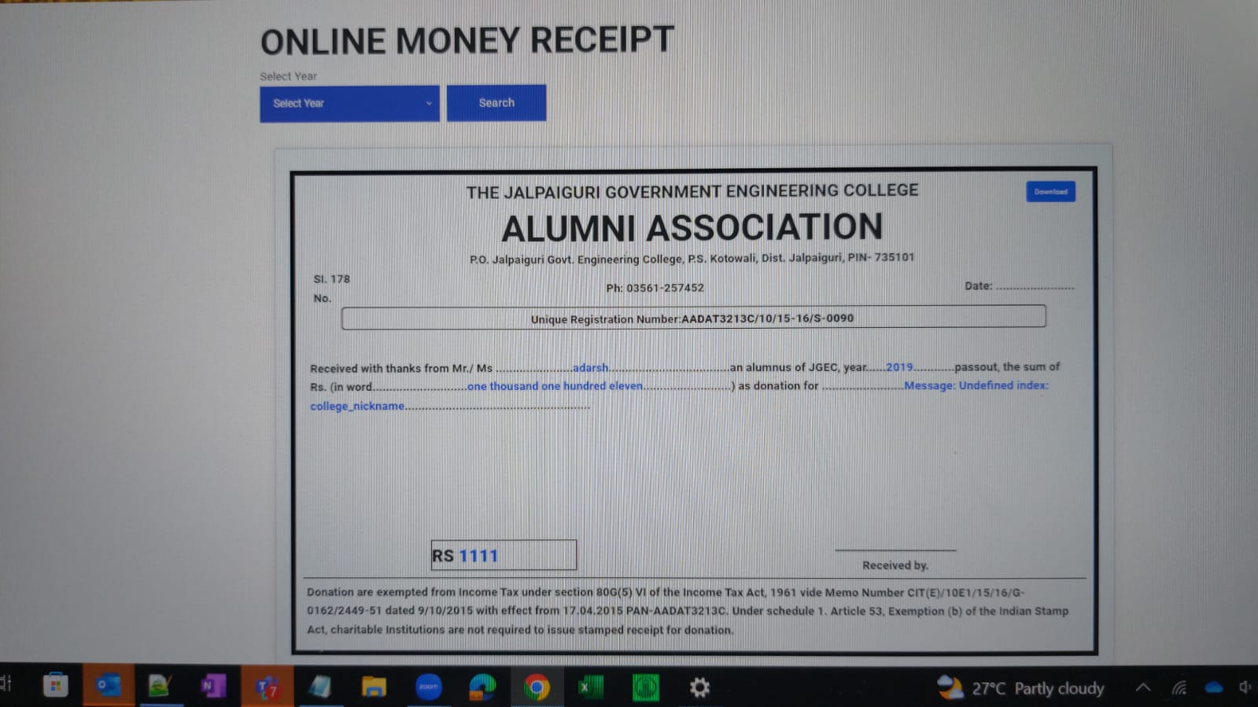

Why do i see an online money receipt ? I logged in through testname (the user which i just created). It has no past donations. And why is the search result not filtered for the user? Functionality gap.

The downloaded online receipt has the "download" blue box in the downloaded pic. Looks like a screenshot. Needs to be fixed.

80G certificate will not require a president signature, but will be mentioned that this is an electronically generated document hence does not require a signature.

Is it possible to insert our logo in this document?

The downloaded online receipt has the "download" blue box in the downloaded pic. Looks like a screenshot. Needs to be fixed.

5.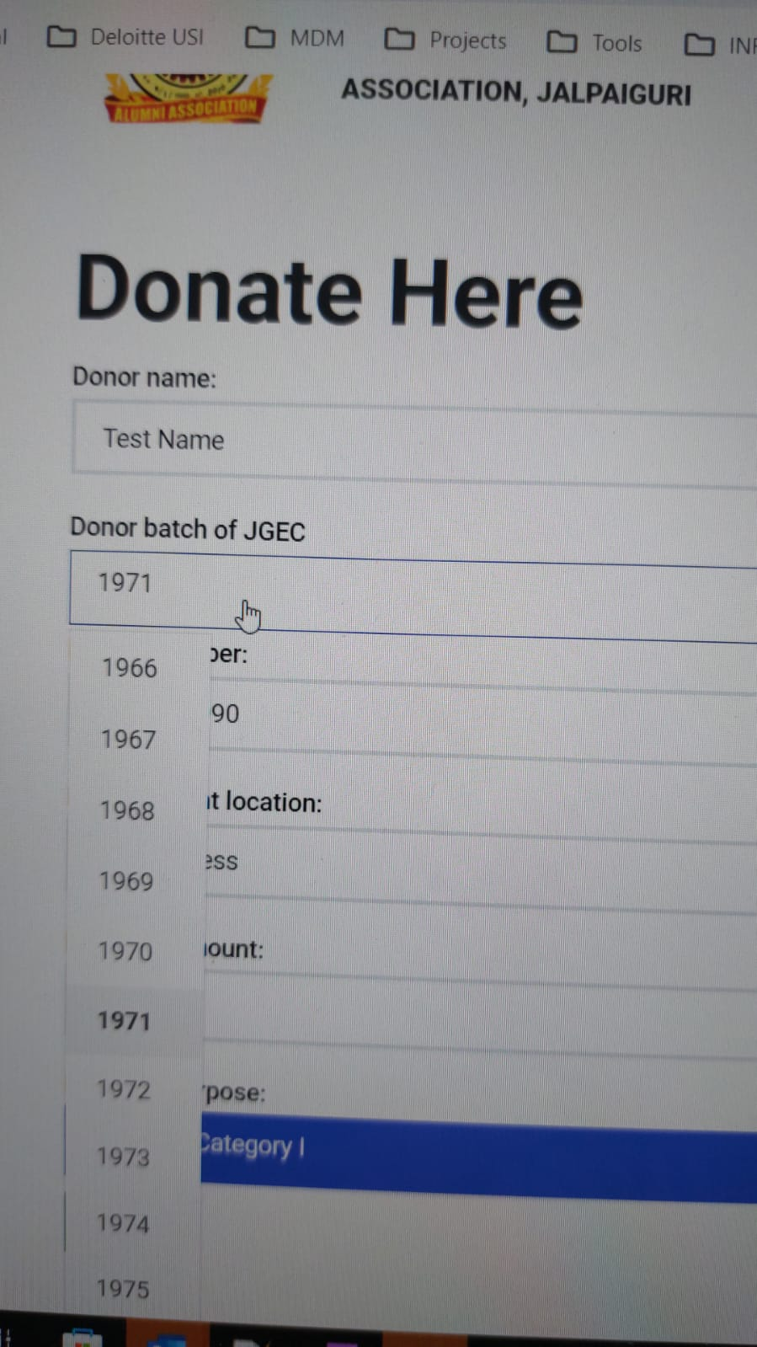

It should not be a drop down. It should be auto populated from backend since it is user-specific data::done

6.Mobile number field doesn't require this counter button::done

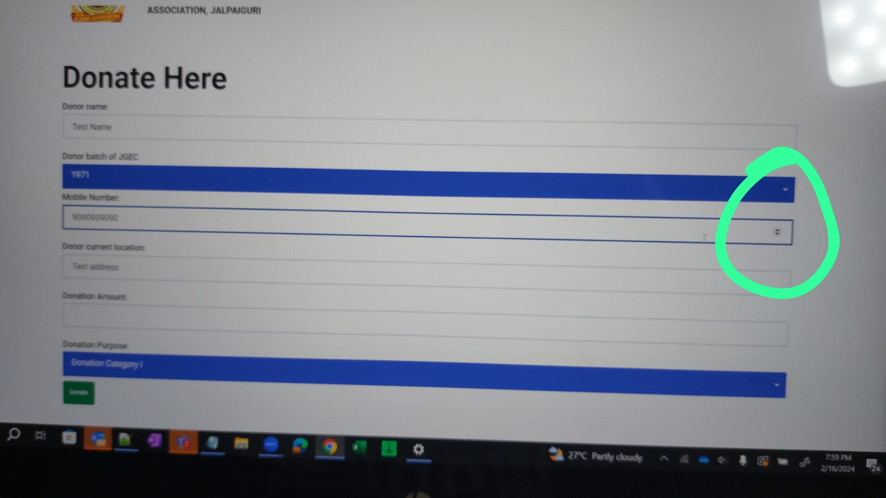

7.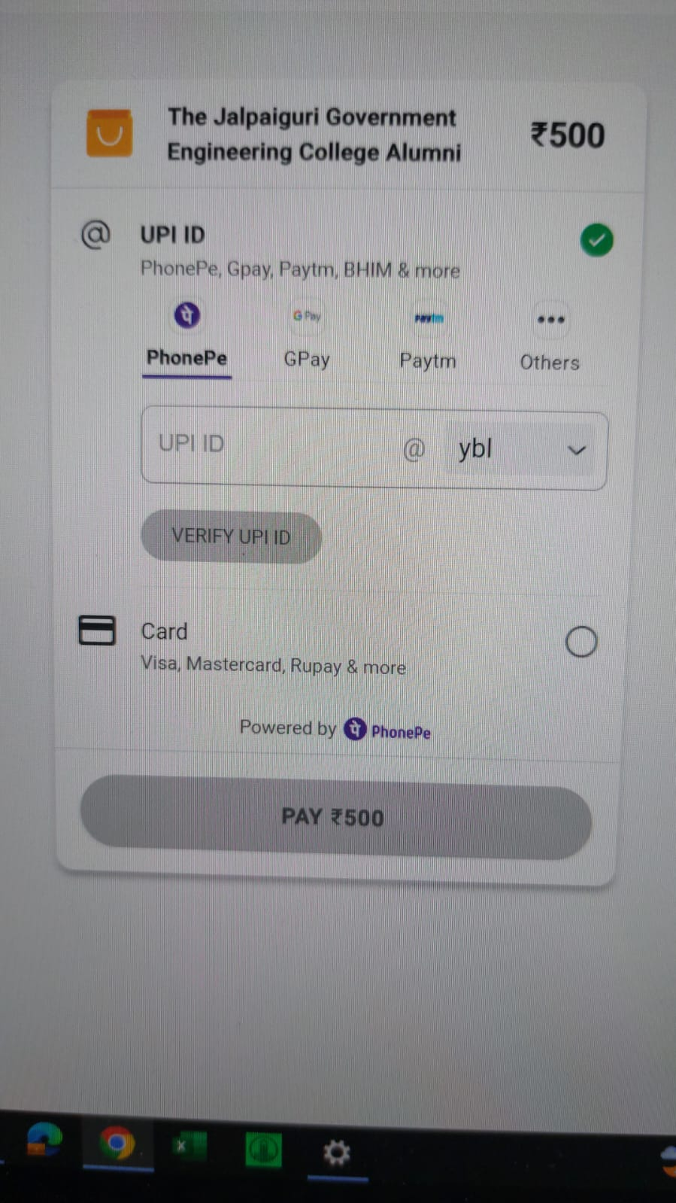

Is net banking not supported ?

8.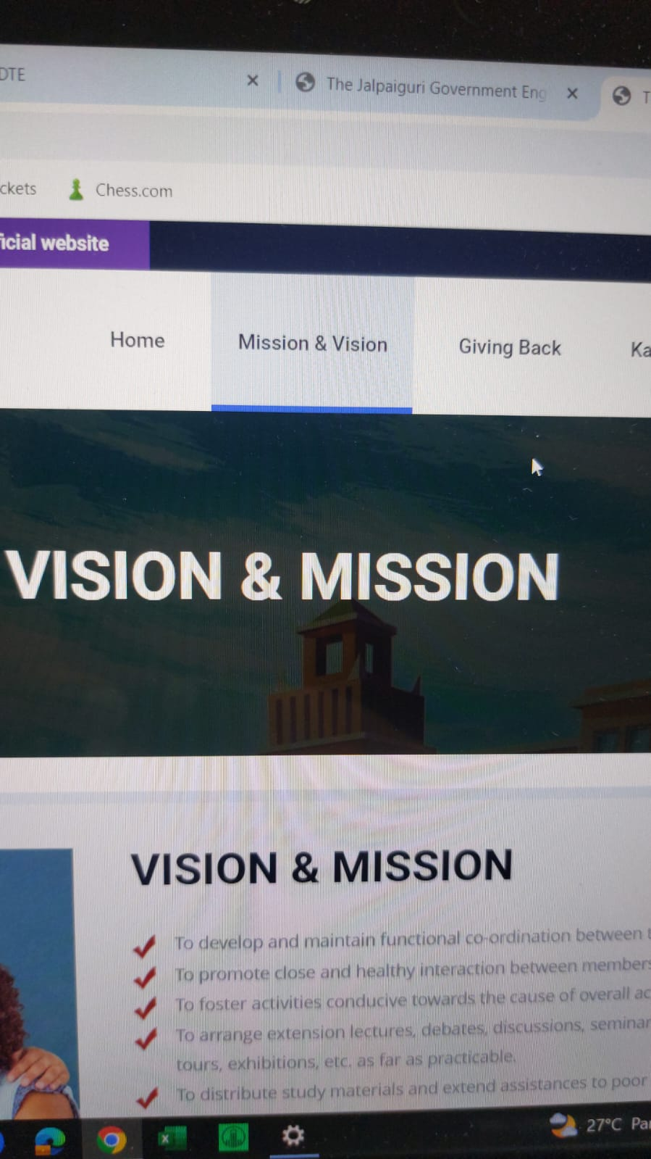

Headings should be consistent. One is mission & vision. Other is vision &mission.::done

9.testalumni1995@gmail.com

Password Hello123

a. Created this profile with jgecpassout year as 2332. Saved successfully, should not be the case.::done

b. Jgec roll no should not be mandatory. 99% alumni won't remember it.

c. After login when i click on donate, the graduation batch is not auto populated.::done